**Food Delivery**

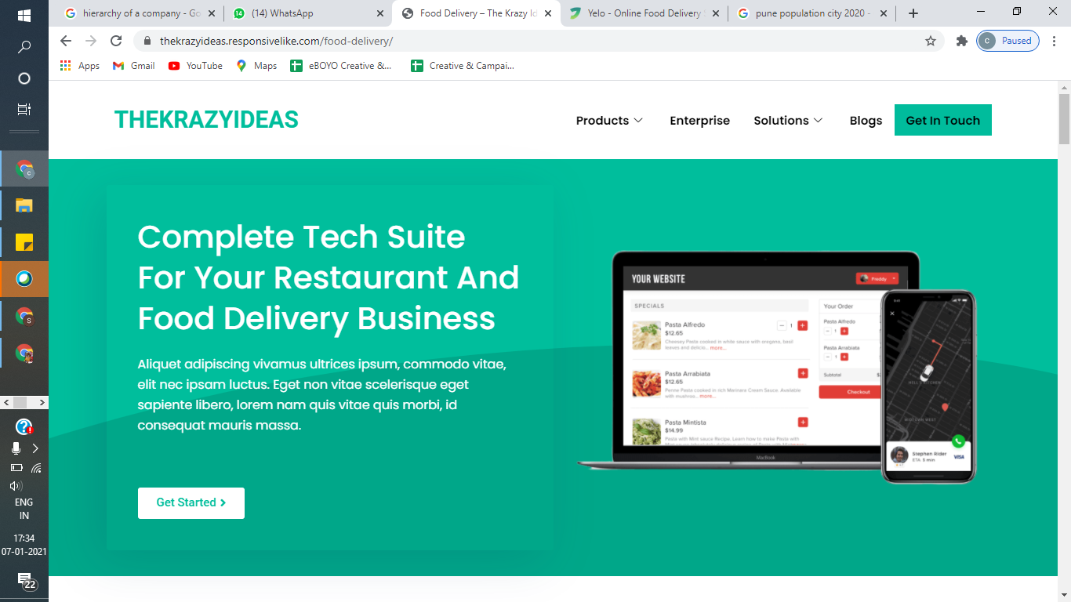

**Full fledged technology package for your Restaurant and Food Delivery Business**

Your own online ordering app and website with end to end delivery management

Know More-Button

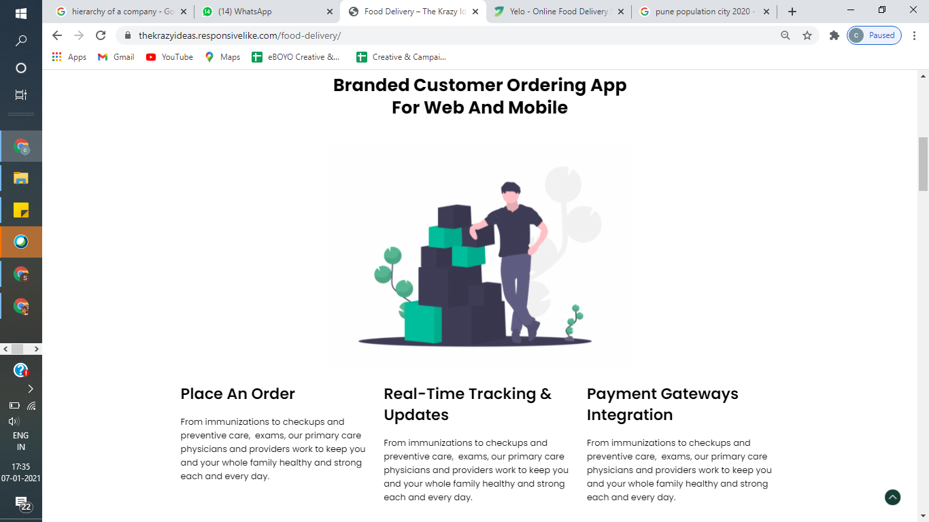

**Your own Customer Ordering App For Web and Mobile (Android and iOS)**

**Online Ordering Real Time Tracking**

Give your customers Zomato like Customers can track their order

Experience and for online food ordering live. System also keep them updated

In the simplest manner possiblewhenever the status changes

**Payment Gateways Integration**

Customers can pay in cash or online

using various payment gateways and wallets

such as Razorpay, Paytm, Lazypay and so on.

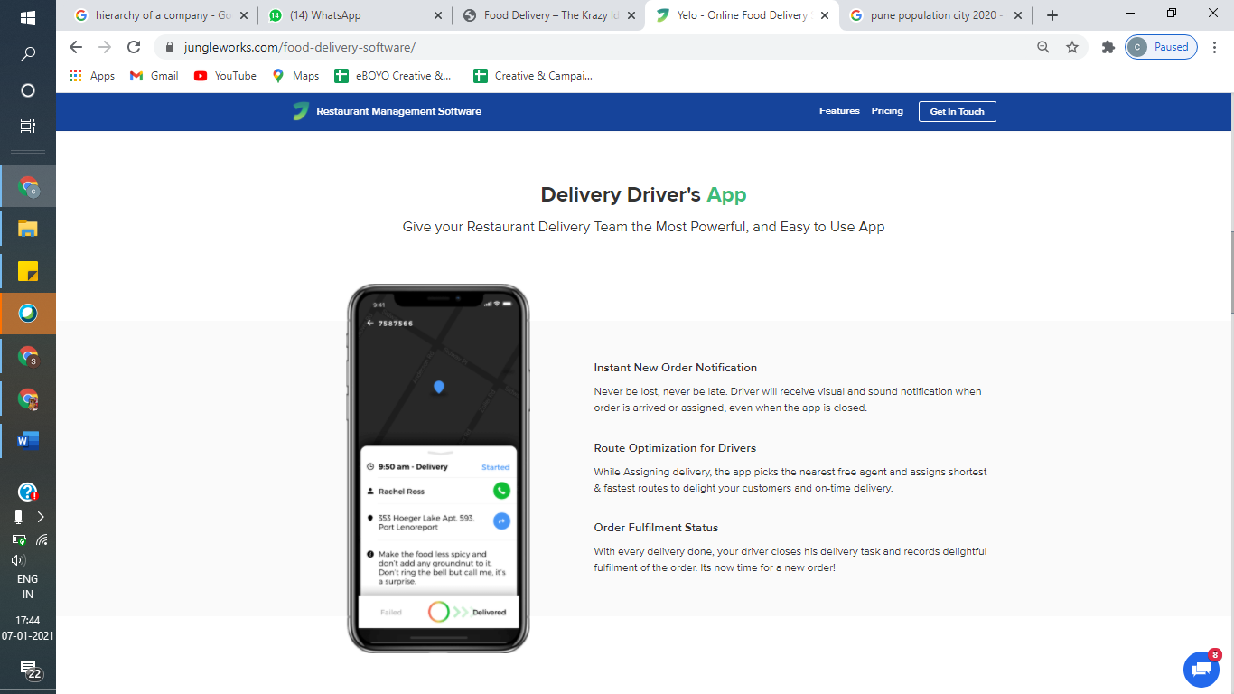

**Rider’s App**

The most powerful delivery app for your riders

**Auto Task Allocation**

Set up the system, sit back and relax. Tasks are auto assigned to your rider as per predefined logic

**Instant Notification**

It is next to impossible the new task with our instant notification

**Order Status**

The moment delivery is done, the rider marks it so and gets ready for the new task.

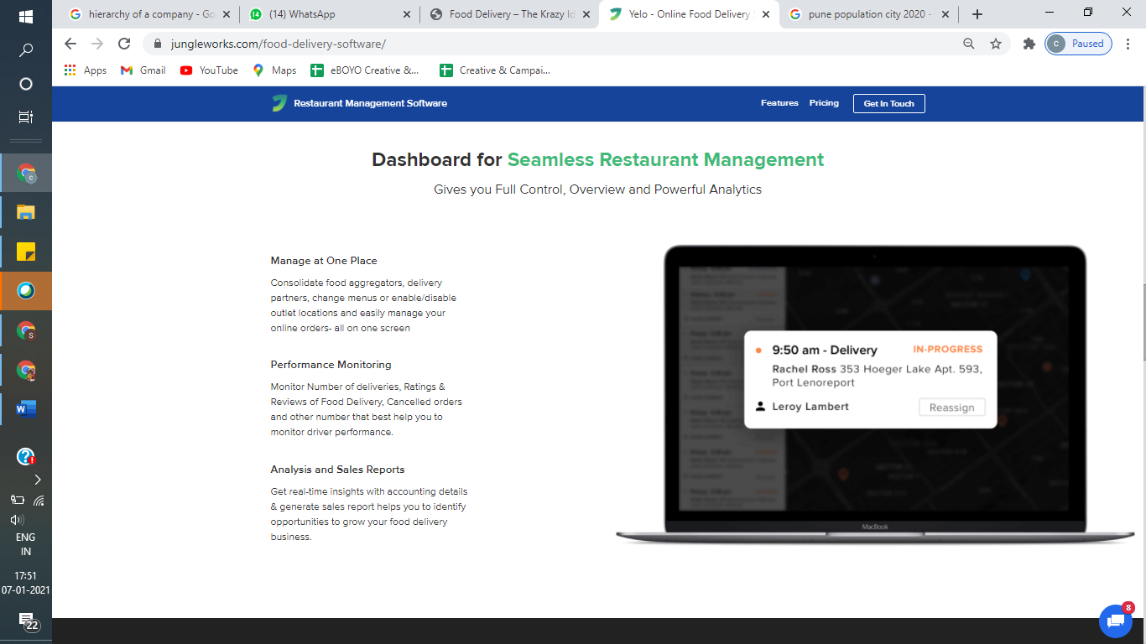

**Feature packed dashboard for your Orders management.**

**Manage at One Place**

View all your Orders, Restaurants and Riders from one dashboard and have full control on your business

**Monitor Performance**

Monitor the performance of your riders and restaurants using Reviews and Ratings, count and amount of cancelled orders and so on.

**Analytics and Sales Reports**

Take informed critical business decisions using our power packed analytics and sales reports

**Medicine delivery:**

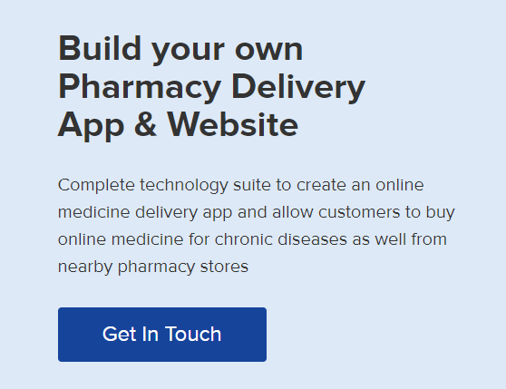

**Setup your medicine delivery app and website**

Create an online medicine delivery app with our technology package wherein, customers can buy medicines from their nearby drug stores and get then delivered at their doorstep

Know more-Button

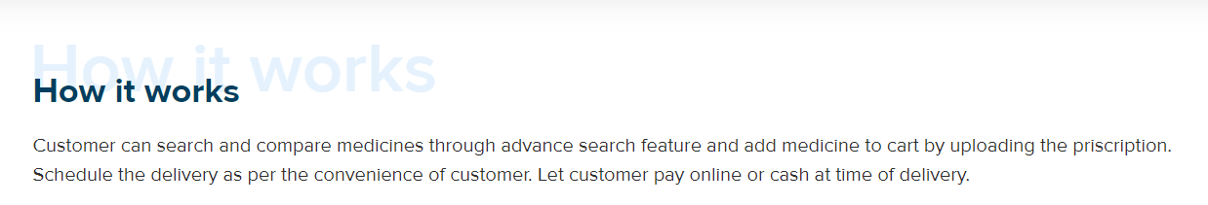

**How it goes**

Customers can search the medicine, upload the prescription and place the order for instant or scheduled delivery. The payment can be online or cash on delivery.

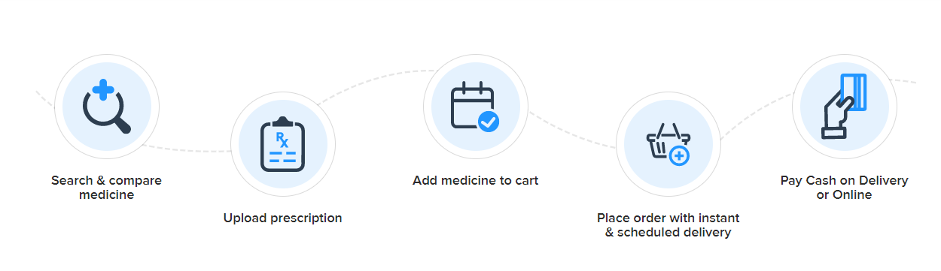

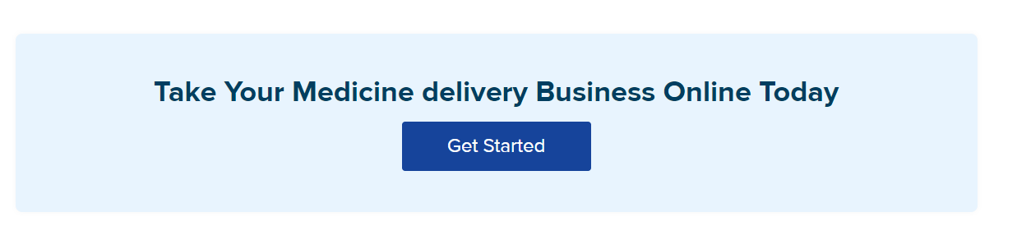

**Start your medicine delivery business and run it from the comfort of your house**

**Get Going-button**

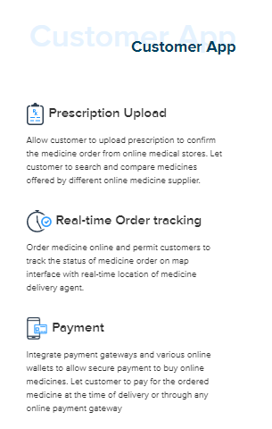

**Upload Prescription**

Here customers can upload their prescription to confirm whether their medicines are available on online stores. App also allows them to compare their cost with various merchants

**Order Tracking**

Customer will get the real time order delivery details via their app

**Secure Payment Method:**

Various payment gateways can be integrated to ensure smooth payments.

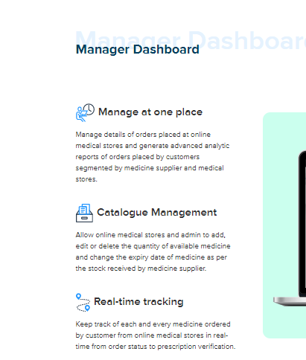

**Manager Dashboard**

**Manage at one point:**

Handle all the orders

Generate real time reports

Customer wise and Store Wise data available

**Customize and manage your catalogue:**

Allow Store Owner to add, modify or delete the drugs available

Store Owners can update expiry date as per stock

**Track Status in real-time:**

Real Time Order tracking for each medicine

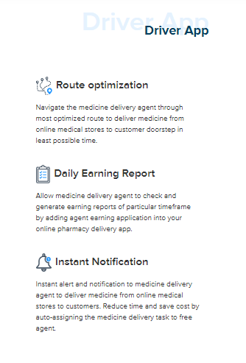

**Delivery partner app**

**Everyday earning report:**

Allow Delivery Agent to access live as well as date wise earning reports as and when required

**Send instant notification:**

Delivery Task can be auto assigned to the nearest delivery agent thereby saves your time and effort. Instant Notification can be sent to the Medicine Delivery agent so that he does not miss any order.

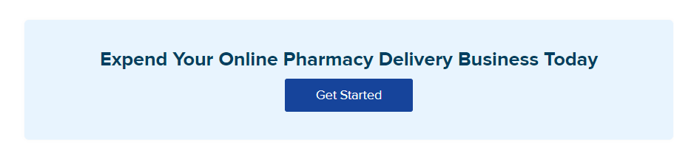

**Let Us Help You Start Your Online Medicine Delivery Business**

**Let’s start-button**

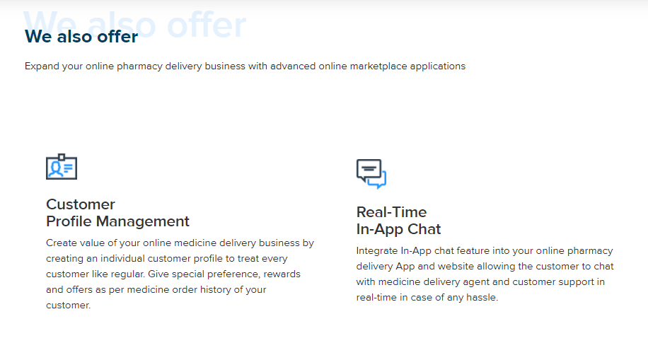

**Expand your business with highly demanded application**

**Each Customer is Special**

Customer Profiling enables you to treat every customer special. It allows you to offer personalized rewards and offers as per Customer Order History

**Customer Chat support:**

**In App Chat support allows you to provide** 24/7 chat support to Customers, Merchants and Riders

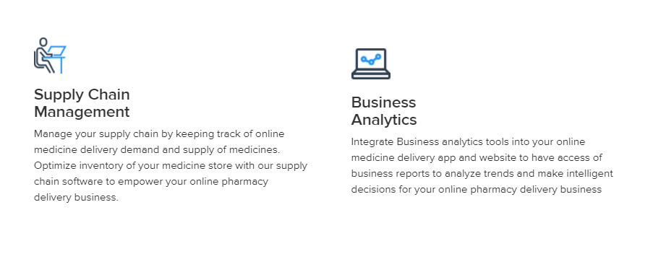

Inventory and Supply Management

Our Power Packed Analytics allows you to track medicine wise demand and availability enabling you to take intelligent and informed decisions for your online Pharmacy business

Business



Get in Touch to Start or Expand Your Online Pharmacy Today

Enquire Now-Button

**Grocery :**

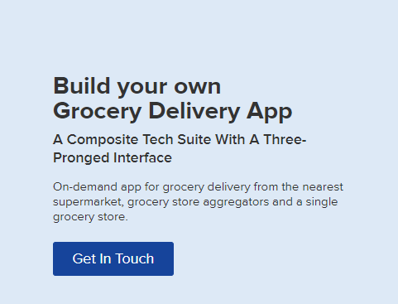

**Setup your own Grocery Delivery APP**

**Our Technology will help you start your own Grocery Delivery App**

On-demand grocery delivery app delivers fresh fruits and vegetables from nearby grocery store

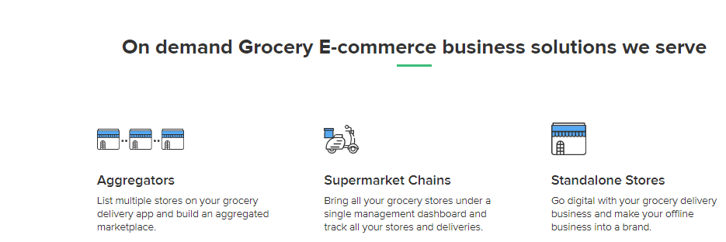

**Our On Demand Grocery Business Solutions Serve**

**Grocery Store Aggregators-** Multiple stores can be listed on your grocery delivery application and a collected marketplace can be formed.

**Super Mart -** All grocery stores can be managed under a single Dashboard and Application which can also track all the stores/Deliveries

**Single Stores-** Digitize your grocery delivery business and convert your offline business into an Online brand

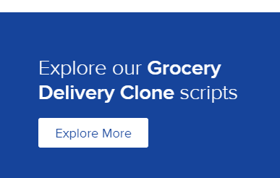

Delve into our **Grocery Delivery** Scripts

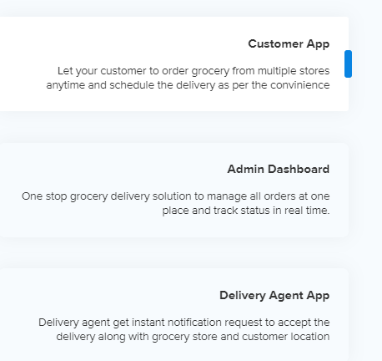

**Consumer App**

Consumer can order grocery anytime and schedule the delivery as per their ease

**Administrator Dashboard**

Allows admin to manage and track all order status in real time

**Delivery partners Application**

Delivery partners get prompt notification to handle the delivery along with grocery store and consumer’s location

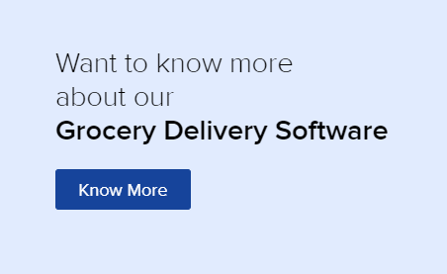

**Get in Touch for the Details of Our Solution**

**Call Me-Button**

**Beauty:**



**On-Demand Salon at your doorstep**

**Provide all the Beauty Services and Appointments through your own Branded Website and App**

**Enquire Now-Button**



**Complete Salon System that serves all the needs**

**On- Demand Beauty and Grooming Services**

Connect customers with beauticians and salon owners, offer salon at doorsteps

**Your own Salons, Spas and Parlours**

Schedule appointments, Accept online bookings and Manage customers through our technology suites under your own brand

**Aggregators**

Setup a marketplace of beauty and wellness service providers by bridging them together under a single platform**.**

**Get connected**

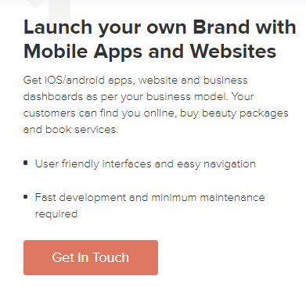

**Launch and Establish your brand with Website and Application**

Get an iOS/Android application, website and dashboards to manage business as per your model. Your Customers can buy Beauty packages and book services online.

**.** Easy to navigate UI

**.** Negligible maintenance and quick development

Enquire Now- Button

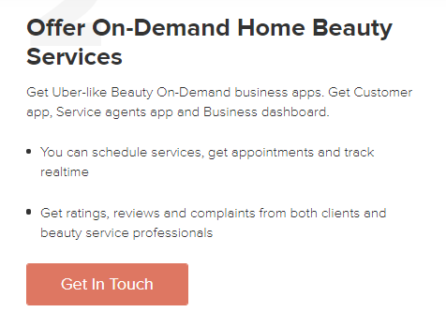

**Offer On-Demand Beauty Service**

Give your customers luxury of availing beauty services at Salons/Parlours or at their Homes. Get Consumer application, Service providers Application and Business dashboards.

* Book Appointments for Scheduled Services and Track Real Time
* Record Ratings, Reviews and Complaints

. Enquire Now- Button

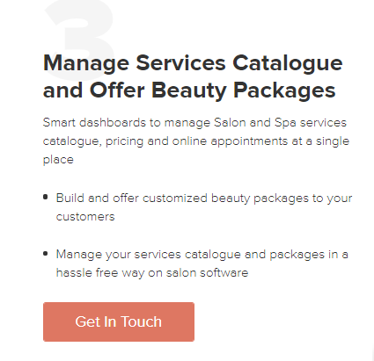

**Manage Catalogues**

User friendly dashboards to create and manage Catalogues and Pricing

* Offer Pre-defined and Customized beauty packages to customers
* Easily Manage Catalogues and Packages on Your Salon Software

Enquire Now- Button

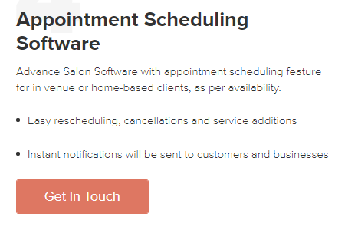

**Appointment Scheduling**

Our Software empowers you with features to pre book Appointments for @Salon Services and @ Home Services as well

* One Click Cancellations, Service Additions, Reorders and Rescheduling
* Reminders for Scheduled Services and Appointments
* Real Time Notifications for Customers

Enquire Now- Button

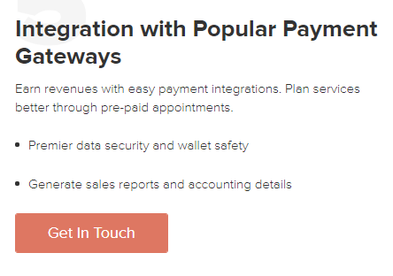

**Online Payment Options**

Integrate with Most Popular Payment Gateways for Online Payments

* Secure Wallet
* One Click Sales and Accounting Data

Enquire Now- Button



Remove The Above



Remove Above

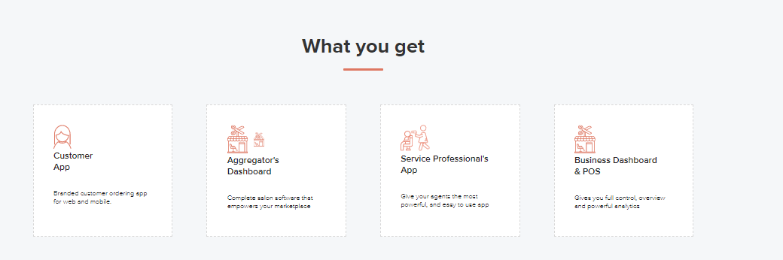

**Our Software Package includes**

**Customer App**

**Aggregator’s Dashboard**

**Service Provider’s App**

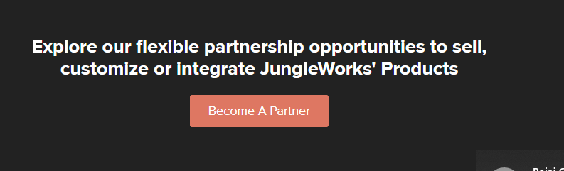

Remove Above

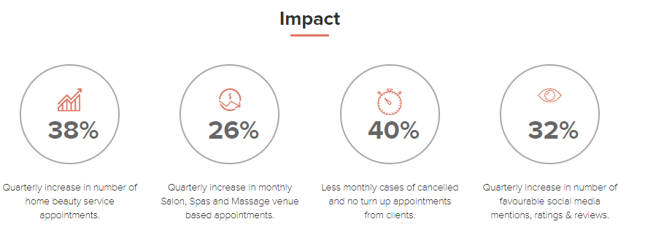

Remove above



Find out what we can do for you

**Flower and Cakes Delivery:**

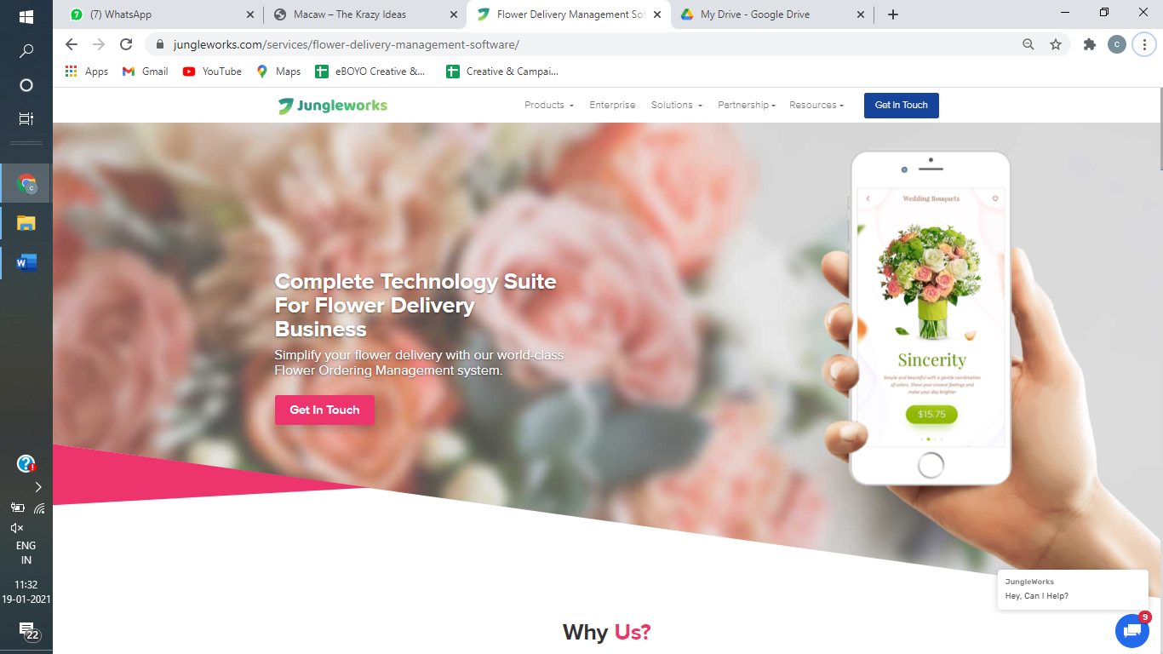

**Complete Software Suite for Your Flowers and Cake Delivery Business**

Take Your Flower and Cakes Delivery Business Online with our Top Class Ordering Management System

Know More-Button

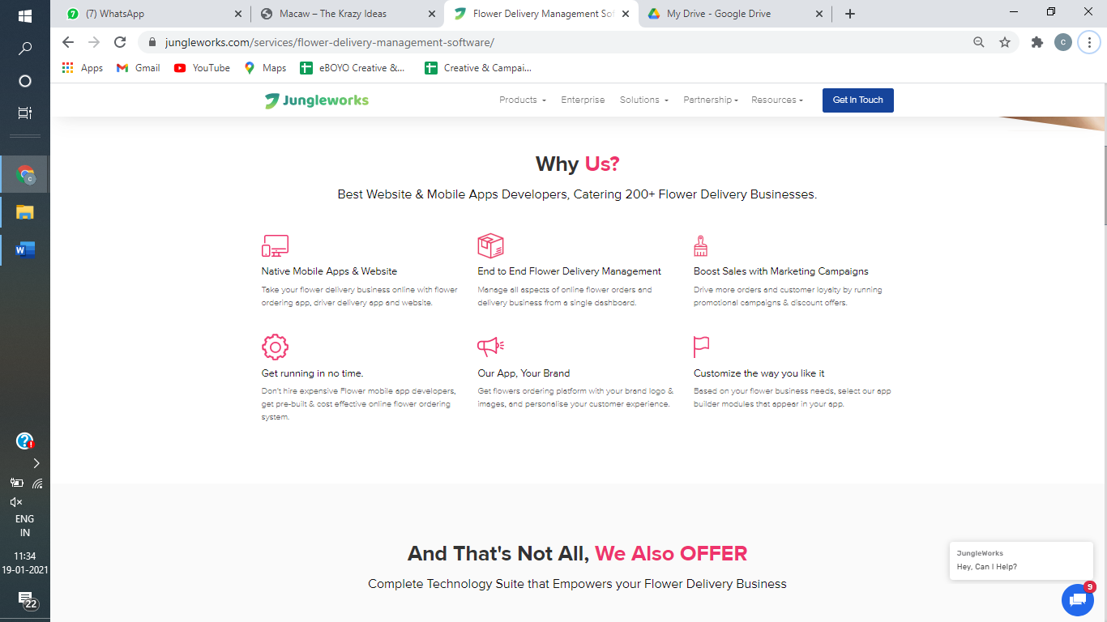

**Why Choose Us?**

Best-in-Class Mobile App Developers and Dedicated Customer Service Team

**Your Own Branded Apps & Website**

User Friendly Apps and Website for Your Customers, Merchants and Drivers

**Full Fledged Delivery Management**

Manage Your Entire Delivery System Online, Right From Showing Catalogue To Customer Till The Receiving Rating After Delivery Of The Product From A Single Dashboard

**Skyrocket Your Sales**

Apply Promo Codes & Give Discount Offers To Boost Your Sales Like Anything  
Get running in no time.

**Cost Effective Solutions**

Why Engage Expensive Mobile App Developers, When You Can Enjoy Pre-Built & Cost-Effective Online Flower Ordering System

**Your Brand on Our App**

Leverage Our Already Matured and Stable Platform with Your Brand Logo, Images and Name to Personalise the Customer Experience

**Our App can Look the Way You Want**

Customizations Are Available To Make The App Look Like As It Pleases You

**Be an Aggregator**

You Can Accept Orders On Your Own Or Be An Aggregator And Onboard Other Merchants On The Same Platform 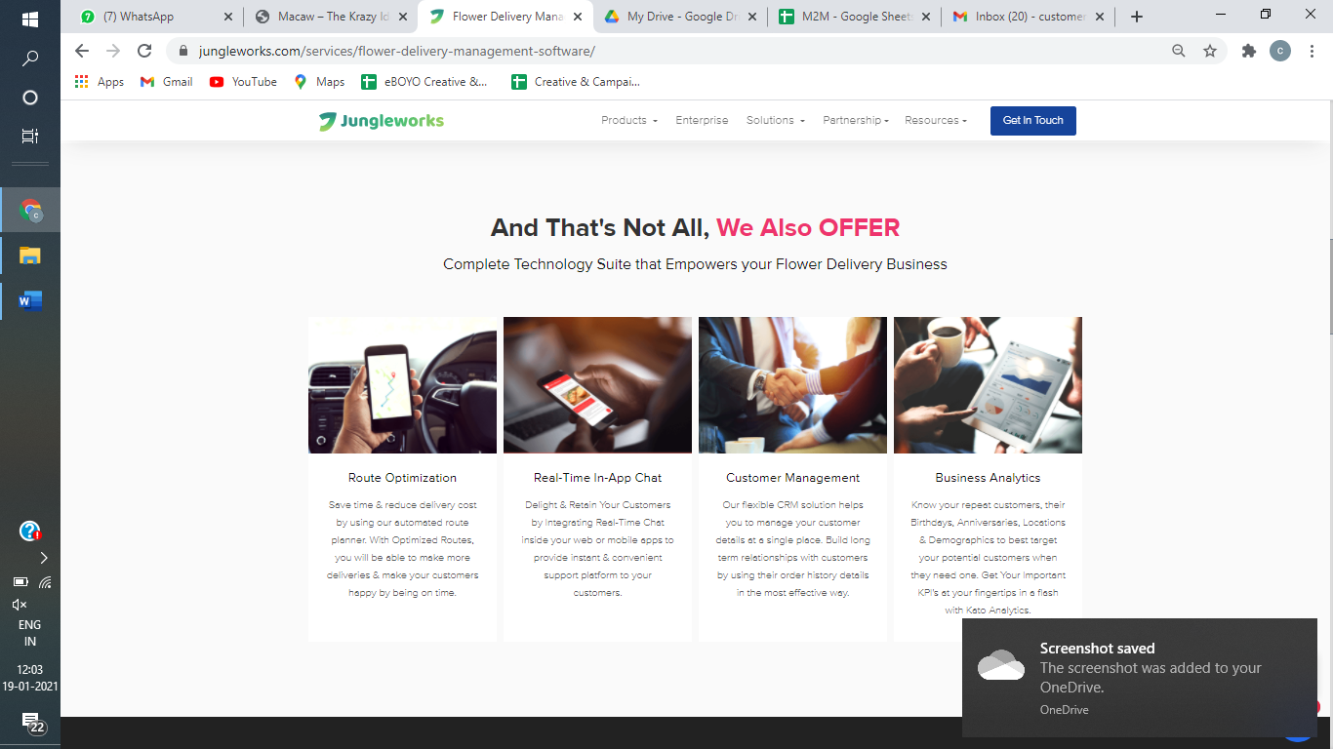

**What Else We Have For You**

Complete Software Solution To Make Your Business Powerful and Smooth

**Route Navigation for Riders**

Let Your Riders Navigate Through The Best Route and Please Your Customer By In-Time Delivery

**In-App-Chat**

Let Your Customers Connect Through In-App Chat To Get Their Issues Resolved

**Business Analytics**

Our Power Packed Analytics is Their to allow you Make Informed Decisions

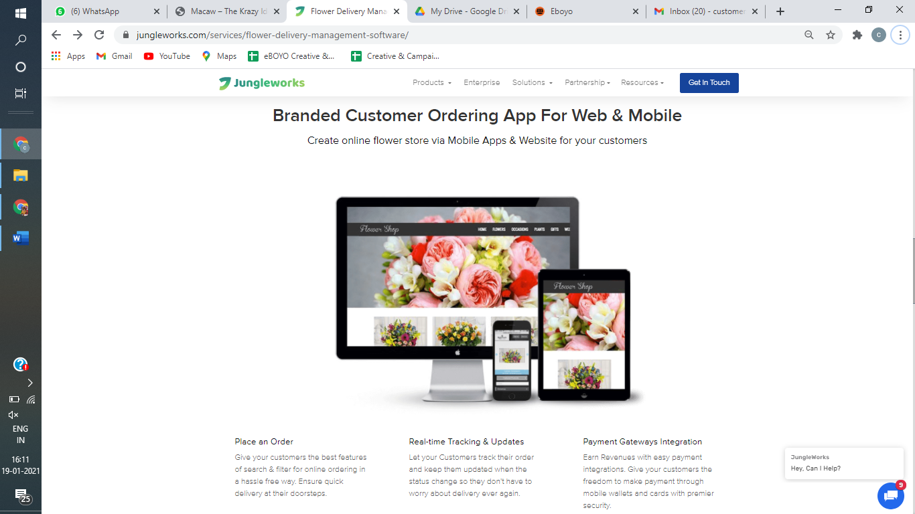

**Your own customer ordering app for Web and Mobile**

Launch an Online Store via Mobile Apps & Websites

**Place an Order**

Best-in-Class Search Features for Online Ordering

**Live Tracking**

Customers can track their order in a real time manner

**Payment Gateways Integration**

All Trusted Payments Gateways are Integrated for online payment

**Dog Walking:**

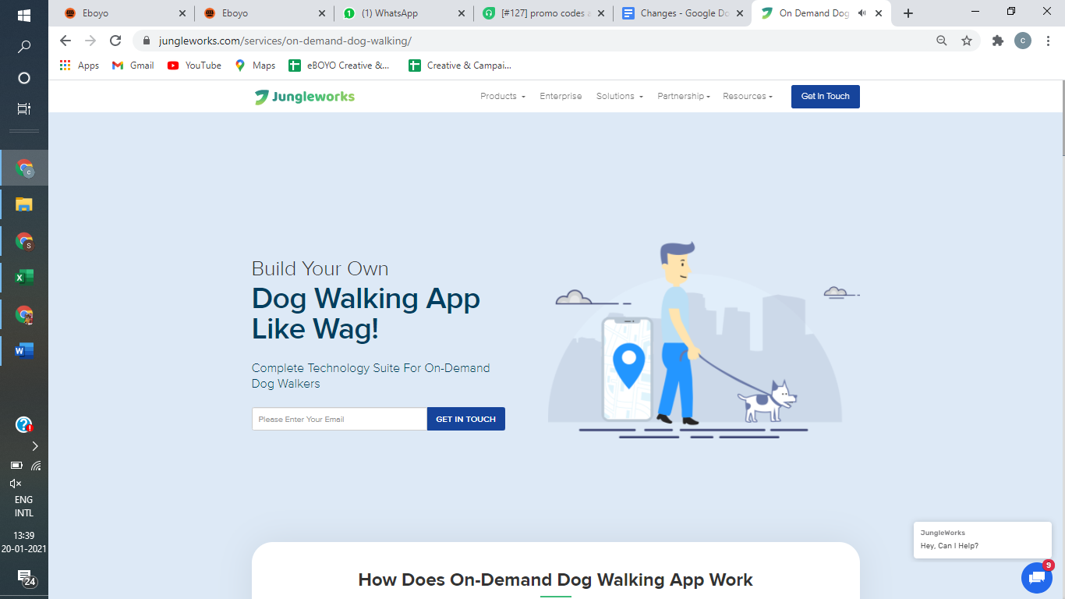

Hide Partnership Menu for Now

Rename Resources as Blogs and remove the options-The Library, Academy, Customer Story, Video and make this page for Blogs Hosting only,